TREES OF MORNINGSIDE GARDEN
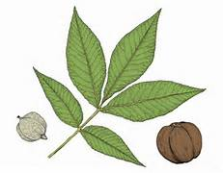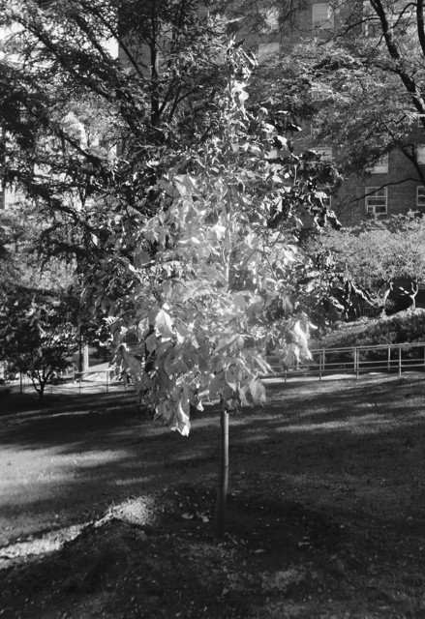

IN CELEBRATION OF THE THE 60th ANNIVERSARY OF MORNINGSIDE GARDENS
A SHAGBARK HICKORY TREE WAS PLANTED ON THE LOWER LAWN IN FRONT OF BUILDING 5 ON OCTOBER 11, 2017


TREES OF MORNINGSIDE GARDENS
Text by Liz Wiesen,
Co-Chair Grounds Committee

Design and Layout by Edward Sowder,
Grounds Committee

Funded by the MHHC Board of Directors,
In Celebration of Morningside Gardens 60th Anniversary

A joint publication of the Grounds Committee and
The Morningside Gardens Cooperators Assembly (MGCA)

October
2017

INTRODUCTION

TREES OF MORNINGSIDE GARDENS is a walking guide showing locations of the over 200 trees of Morningside Gardens. This guide was first composed by Juanita White, a member of the Morningside Gardens Tenant-Cooperators Committee Grounds Committee (MGTCC is now MGCA) and published by MGTCC in 1987. Juanita was assisted in this endeavor by several knowledgeable cooperators, including current Grounds Committee member Elinor Levin. TREES OF MORNINGSIDE GARDENS was updated in 1993, 1997, and 2000.

Now in 2017, in celebration of Morningside Garden’s 60th Anniversary, the Grounds Committee has created an updated version based on Juanita White’s original hand-drawn guide. This guide gives the user the general location of all our trees, while also building in a delightful element of discovery, as trees are (for the most part) not individually identified on the maps.

Tree tours are a tradition at Morningside Gardens, a celebration of cooperators’ successful conversion of what was a brick-strewn, muddy construction site, when construction began in 1955, and cooperators turned the grounds into a real gardens with a diversity of interesting and beautiful trees. In the early years, neighbors held fund-drives to purchase trees. Many began donating funds for trees to honor family and friends. Chances are good that the tree that catches your eye was planted with someone’s loved one in mind. We hope you enjoy exploring the glorious trees of Morningside Gardens and that the TREES OF MORNINGSIDE GARDENS helps you to do so.
